Virtual world piloting activities of the DIGI4ME project - Health sector skill alliance for creating innovative and efficient VET programs and improving the digital Skills of medical physics and health professionals

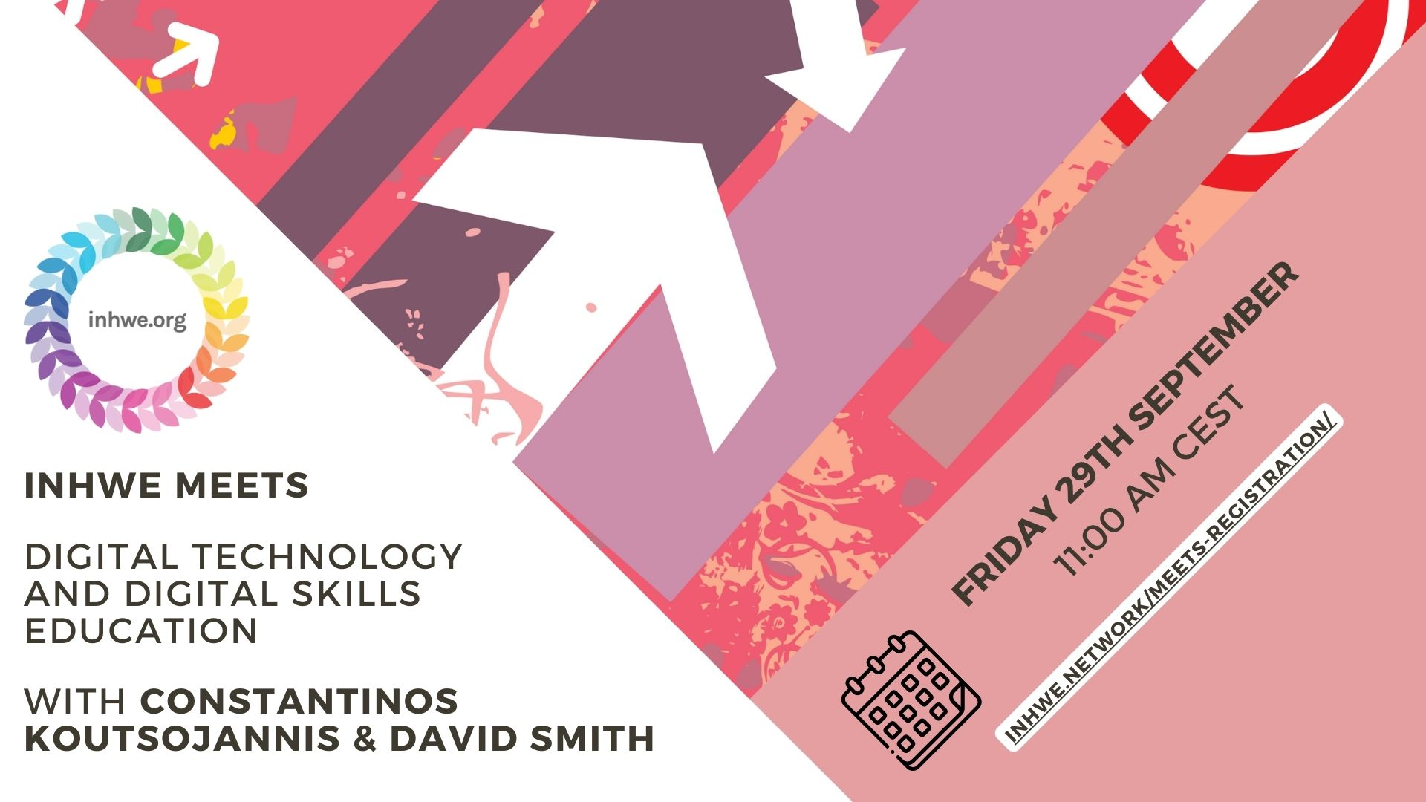

The final closing conference of the DIGI4ME project - Health sector skill alliance for creating innovative and efficient VET programs and improving the digital Skills of medical physics and health professionals took place on Friday September 29th, 2023 in Athens, Greece.
This was a completely free event that provided participants with all the skills they need to teach and understand digital literacy in multiple healthcare settings and within interprofessional groups. The project's teachers, doctors, nurses, medical physicists and other professionals were actively involved in identifying training needs and provided constant feedback throughout the development of the programs. They brought a practical perspective and ensured the relevance of the content to the health sector. The main purpose of the conference was to provide stakeholders with a demonstration of the Digi4Me platform for digital skills training in the healthcare sector. The DIGI4ME project involved partners from several European countries, which allowed the exchange of ideas and best practices at an international level. This aspect brought a global perspective and increased the level of expertise in the project. EU education institutes, VET, healthcare associations and relevant EU businesses will exchange skills, experience and accessibility to be embedded in a single high-quality training framework to improve digital skills training in all countries European.
During the conference, issues related to the results of the project, the digital skills that health professionals should have in the future and the dissemination and improvement of the project results were discussed. One of the most notable results of the DIGI4ME project was the improvement of the quality of healthcare. Through our digital training programs, healthcare professionals can gain advanced skills in managing digital medical data, diagnosing and treating patients. This will lead to significant improvement in medical processes, reduction of errors and ultimately more efficient and accurate healthcare for patients.
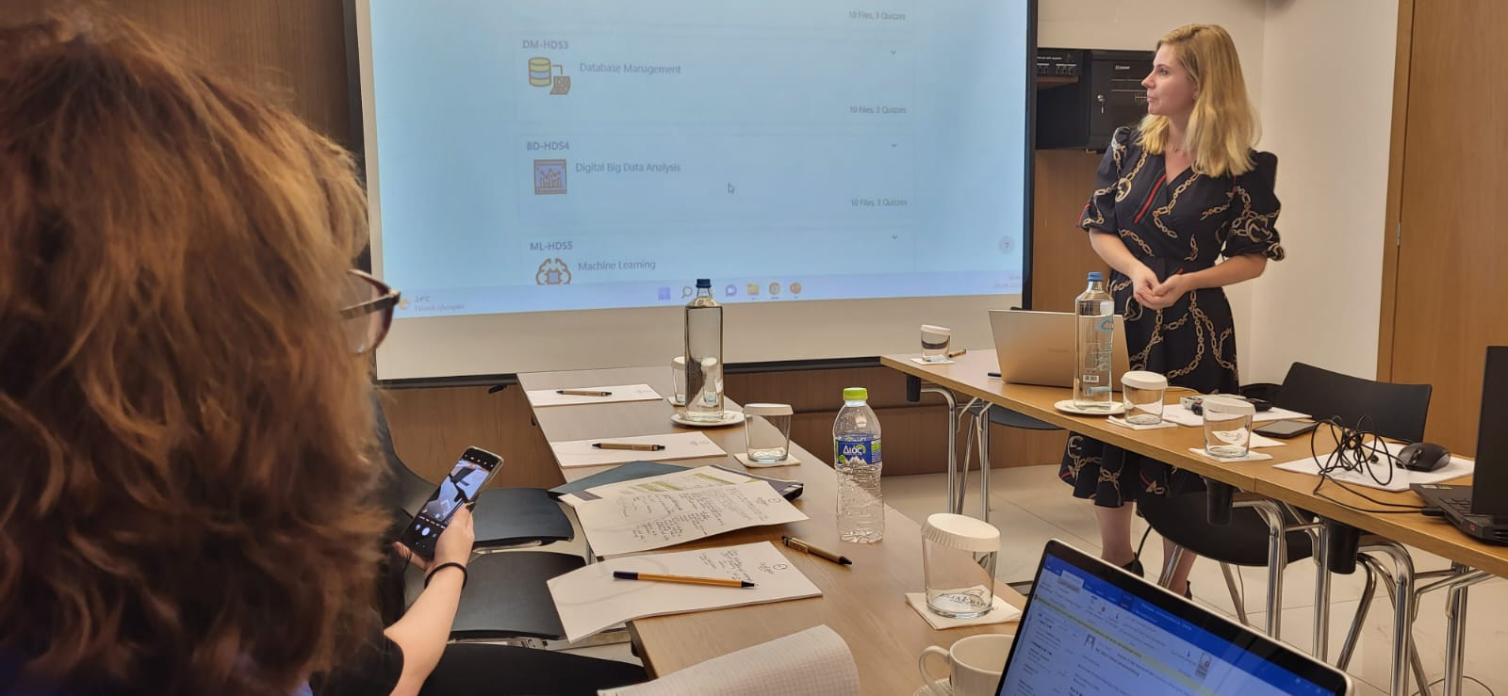
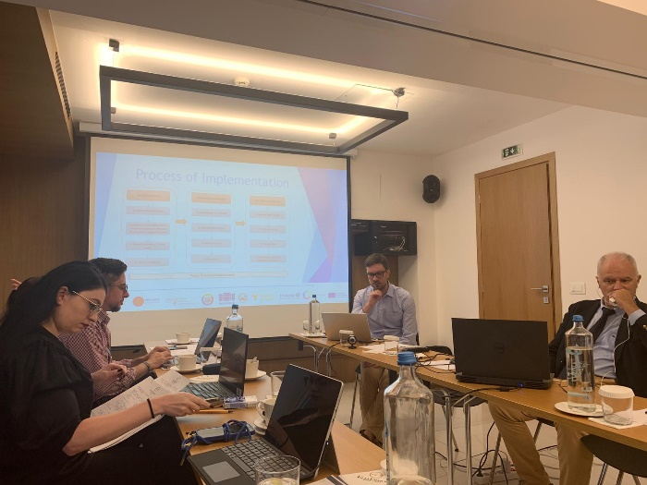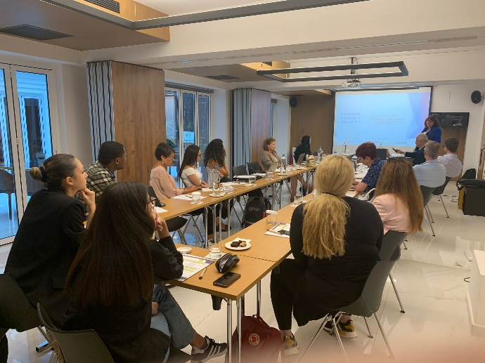
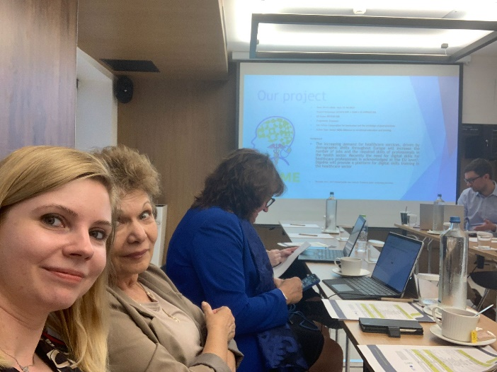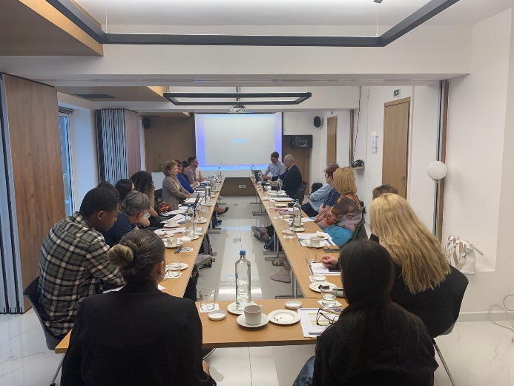
The educational platform developed within the project will be available online to all people interested in developing their digital skills and developing their knowledge in the field of health starting this October. The DIGI4ME project will help health professionals adapt more easily to the ever-changing digital technologies. They will learn to use medical data management systems, telemedicine technologies and other digital tools to streamline their work processes and provide patients with better accessibility to medical services. Data management, scheduling and patient communication will improve significantly, leading to time and resource savings for healthcare professionals and patients. Also, in the countries participating in the project (Greece, Cyprus, Romania and Germany), events will be organized to promote and pilot the virtual world, during which 1) the strengths and weaknesses in the design of the DIGI4ME virtual world will be identified; 2) the opportunity for further improvement will be identified; 3) the learning experience of students for schools of medicine, medical physics and health professionals will be evaluated in terms of their interaction in several carefully selected modules while piloting. This involves assessing students' knowledge of the subject matter explored in each specific course module selected. The courses available in the virtual world will be evaluated by the learners according to the criteria established in the penultimate project meeting. The feedback obtained during these events will be recorded in the form of a report, following which the ways to improve and disseminate the educational platform will be identified .
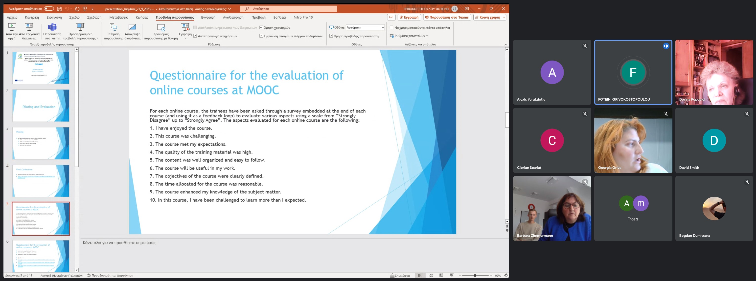
In Romania, pilot events will be organized at the Politehnica University of Bucharest (UPB) and students from the Faculty of Engineering in Foreign Languages (UPB) and the Faculty of Medicine at Titu Maiorescu University will be invited.

About the project
The main aim of the DIGI4ME project is to address the skills gap in the healthcare workforce and provide an innovative training framework together with a certification scheme. The project will address the first 4 CEC levels. It will formulate a wide range of courses to improve the skills of health professionals. New programs will be formulated to address cutting-edge methods and content in the health sector.
The project brings together specialists from Romania, Greece, Cyprus, Germany:
- University of Patras, (UPAT), Greece
- Computer Technology Institute &amp; Press Diophantus, (CTI), Greece
- Hochschule 21, Germany
- International Network for Health Workforce Education, (INHWE), Cyprus
- University of Cyprus, (UCY), Cyprus
- Unicert, Greece
- Politehnica University of Bucharest, (UPB), Romania
- Fundatia Pro laser, Romania
- Cyprus Association of Medical Physics & Bio-Medical Engineering (CAMPBE), Cyprus

Project manager:
Conf.dr. Dorina Popovici

http://www.digi4me.eu
www.twitter.com/digi4me1
www.facebook.com/digi4me
www.instagram.com/digi4me.eu
www.linkedin.com/in/digi4me-project-60222120a

